PYTHON ACTIVITY BASED LEARNING
PROBLEM—6
Multi-Stage Scholarship Shortlisting: Apply minimum academic eligibility, attendance requirements, income conditions, and ranking rules to select candidates within a fixed scholarship quota.
Objective:
To develop a Multi-Stage Scholarship Shortlisting System that evaluates students based on minimum academic marks, attendance requirements, family income criteria, and ranking rules to identify eligible candidates and select the most deserving students within a fixed scholarship quota fairly and accurately.
Algorithm:
• Start.
• Read the number of students.
• For each student, input name, academic marks, attendance percentage, and family annual income.
• Input minimum marks, minimum attendance, maximum eligible family income, and scholarship quota.
• Initialize two lists: eligible and rejected.
• Check each student against all eligibility criteria:
- Marks must be greater than or equal to minimum marks.
- Attendance must be greater than or equal to minimum attendance.
- Family income must be less than or equal to maximum income.
• Add students who satisfy all conditions to eligible; otherwise, add them to rejected.
• Sort eligible students using these ranking rules:
- Higher academic marks first.
- Higher attendance first when marks are equal.
- Lower family income first when marks and attendance are equal.
• Calculate the number of scholarship recipients as the smaller of the quota and the number of eligible students.
• Display all eligible candidates in ranked order.
• Display the selected scholarship recipients.
• Display the available, awarded, and remaining scholarships.
• Display the rejected candidates.
• Stop.

Pseudocode:
BEGIN
INPUT number_of_students
INITIALIZE students = empty list
FOR each student
INPUT name, marks, attendance, income
ADD student details to students
END FOR
INPUT min_marks
INPUT min_attendance
INPUT max_income
INPUT quota
INITIALIZE eligible = empty list
INITIALIZE rejected = empty list
// Stage 1: Eligibility checking
FOR each student in students
IF marks >= min_marks AND
attendance >= min_attendance AND
income <= max_income THEN
ADD student to eligible
ELSE
ADD student to rejected
END IF
END FOR
// Stage 2: Ranking
SORT eligible BY
marks in descending order,
attendance in descending order,
income in ascending order
// Stage 3: Scholarship selection
selected = MIN(quota, LENGTH(eligible))
DISPLAY eligible candidates in ranked order
DISPLAY "FINAL SCHOLARSHIP RECIPIENTS"
FOR i = 0 TO selected - 1
DISPLAY rank and student name
END FOR
DISPLAY total eligible candidates
DISPLAY scholarships available
DISPLAY scholarships awarded
DISPLAY scholarships remaining
DISPLAY rejected candidates
STOP
Flowchart:
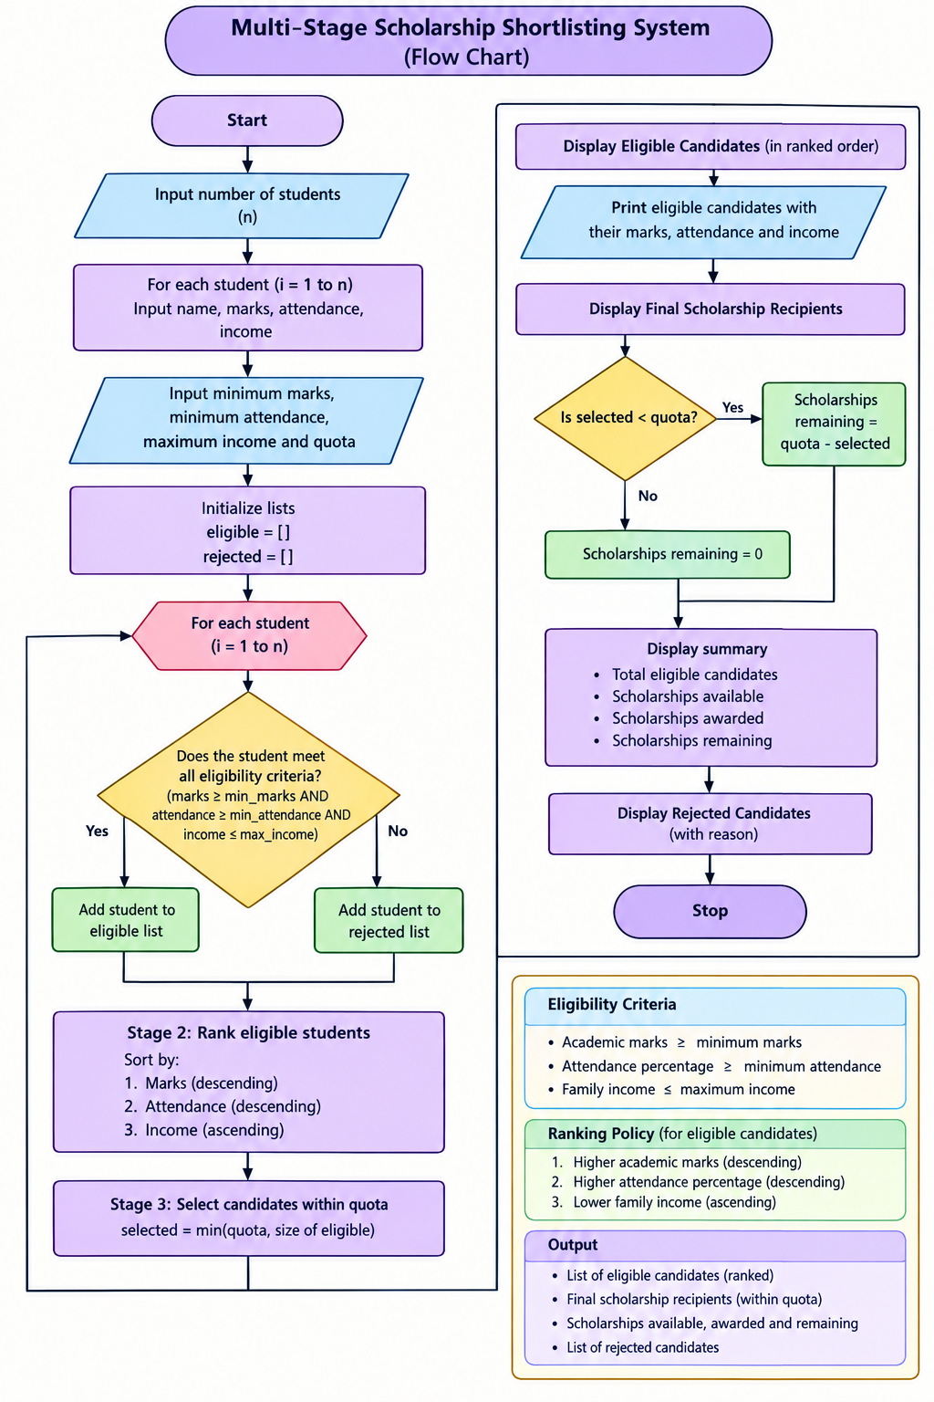

Python Program:
# Multi-Stage Scholarship Shortlisting System
n = int(input("Enter number of students: "))
students = []
for i in range(n):
print("\nEnter details for student", i + 1)
name = input("Enter student name: ")
marks = float(input("Enter academic marks: "))
attendance = float(input("Enter attendance percentage: "))
income = float(input("Enter family annual income: "))
students.append([name, marks, attendance, income])
min_marks = float(input("\nEnter minimum marks: "))
min_attendance = float(input("Enter minimum attendance: "))
max_income = float(input("Enter maximum family income: "))
quota = int(input("Enter scholarship quota: "))
eligible = []
rejected = []
# Stage 1: Check eligibility
for student in students:
name, marks, attendance, income = student
if (marks >= min_marks and
attendance >= min_attendance and
income <= max_income):
eligible.append(student)
else:
rejected.append(student)
# Stage 2: Rank eligible students
# Marks descending, attendance descending,
# income ascending
n = len(eligible)
for i in range(n):
for j in range(n - i - 1):
a = eligible[j]
b = eligible[j + 1]
swap = False
if a[1] < b[1]:
swap = True
elif a[1] == b[1]:
if a[2] < b[2]:
swap = True
elif a[2] == b[2] and a[3] > b[3]:
swap = True
if swap:
eligible[j], eligible[j + 1] = (
eligible[j + 1], eligible[j]
)
# Stage 3: Select candidates within quota
print("\nSCHOLARSHIP SHORTLISTING RESULTS")
print("-" * 55)
print("Eligible candidates:", len(eligible))
for i, s in enumerate(eligible):
print(i + 1, s[0], "Marks:", s[1],
"Attendance:", s[2], "Income:", s[3])
print("\nFINAL SCHOLARSHIP RECIPIENTS")
print("-" * 55)
selected = min(quota, len(eligible))
for i in range(selected):
print("Rank", i + 1, "-", eligible[i][0])
print("\nScholarships available:", quota)
print("Scholarships awarded:", selected)
print("Scholarships remaining:", quota - selected)
print("\nREJECTED CANDIDATES")
for s in rejected:
print(s[0], "- Does not meet all eligibility criteria")

Output Screen Shots:
